**Case Study Report On**

**Holiday Spot Booking Application**

**Index**

**1. Introduction**

**2. Features**

**3. Software Requirement**

**4. Hardware Requirement**

**5. User Story**

**6. Use Case Diagram**

**7. Conclusion**

**HOLIDAY SPOT BOOKING APP - CASE STUDY**

**Introduction**

Holiday Spot booking app will provide destination places available in various regions with its descriptions. Holiday Spot booking app will have an admin module and a user module. The service available is of destination places with its description and time duration.

A user from its end can search along the place to visit from available places and select for the hotel where he can book room to stay. User will have to select its duration of stay.

Admin’s role is to create destination places, generate hotel rooms to stay for user, provide destination description through which user can get details of place.

Users’ interaction starts from searching through existing location selection, based on his selection user can register with his details to select other process like time duration selection, type of room details and other services.

**Features**

* Admin can add Holiday spot locations, provide availability of check in, check out date and provide destination description.
* Users can search and select destination and further through registration can choose the destination spot also he can cancel booking.

**Software Requirements**

* JDK 11
* MongoDB
* Junit
* Spring Tool Suite
* Webserver Apache Tomcat
* Postman
* Git Bash
* JaCoCo

**Hardware Requirement**

* Processor Intel series
* Ram 8 GB or above
* Hard Disk 100 GB or above
* Display Resolution 1024 x 800

**User Stories**

Holiday Spot booking Application will have mainly two modules i.e., an admin and a user module. Also, it will have microservices like API Gateway, Eureka Server, Swagger Documentation, Logger, Registration, Login,

**Microservices-**

Admin

Add Destination, Location

Check in and check out

User

Search

Select destination

Registration and Login

Book spot

API Gateway, Eureka, Logger, Swagger, JWT

**Use Case Diagram**

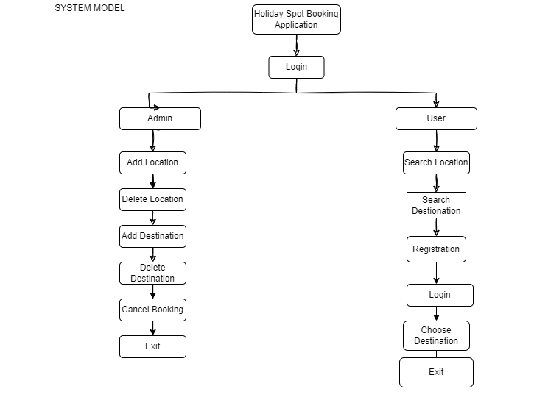

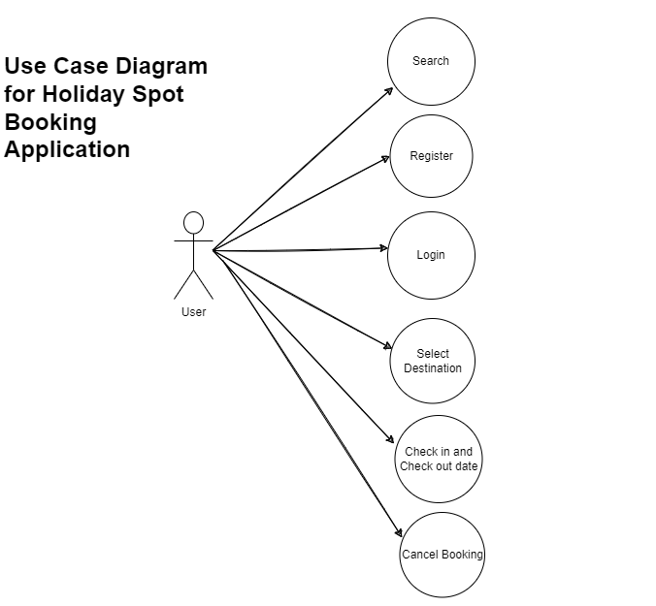

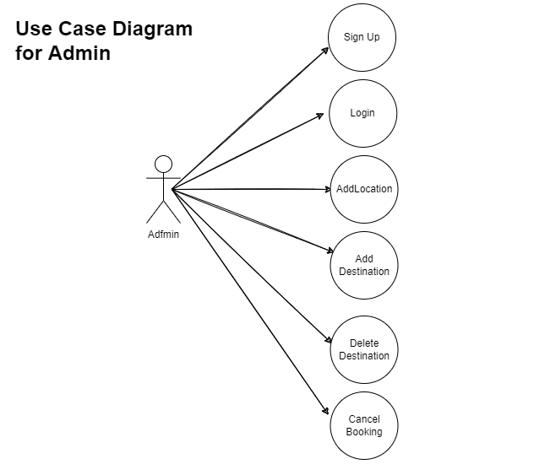

**Conclusion**

Holiday Spot Booking Application provides feature of choosing holiday destination to visit the location. Admin can add as many destinations as possible and locations. Allow user to stay for the duration also avail various services on updating.

Based on choice user can search and select a destination, book room to stay for the specific duration, choose the type of room service as required and can see updates when admin add.

**Architectural Diagram for User Module**

**Code Coverage**

For Admin Location Module

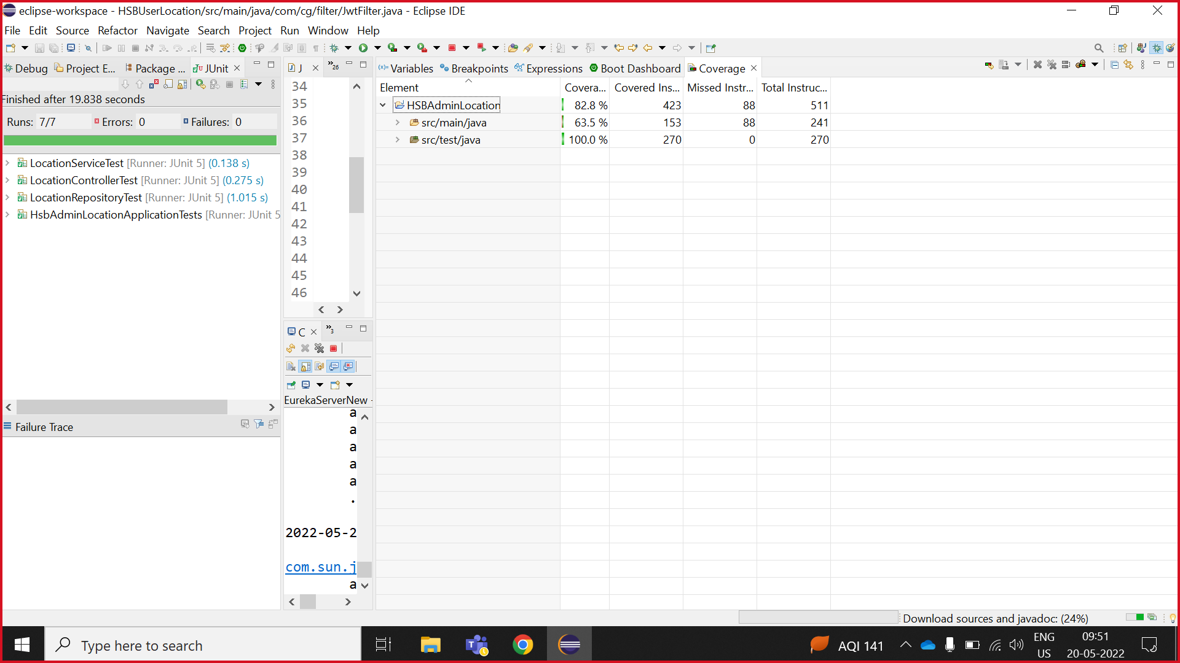

For Admin Destination Module

